**Training Winhe SEA**

**Exercise 5**

**7) What do mean by the scope of a variable. Explain with examples.**

The part of the program where a particular variable is accessible is termed as the Scope of that variable. A variable can be defined in a class, method, loop etc.

C# scope rules of variables can be divided into three categories as follows:

1. Class Level Scope
2. Method Level Scope
3. Block Level Scope

Class Level Scope

* Declaring the variables in a class but outside any method can be directly accessed anywhere in the class.
* These variables are also termed as the fields or class members.
* Class level scoped variable can be accessed by the non-static methods of the class in which it is declared.
* Access modifier of class level variables doesn’t affect their scope within a class.
* Member variables can also be accessed outside the class by using the access modifiers.

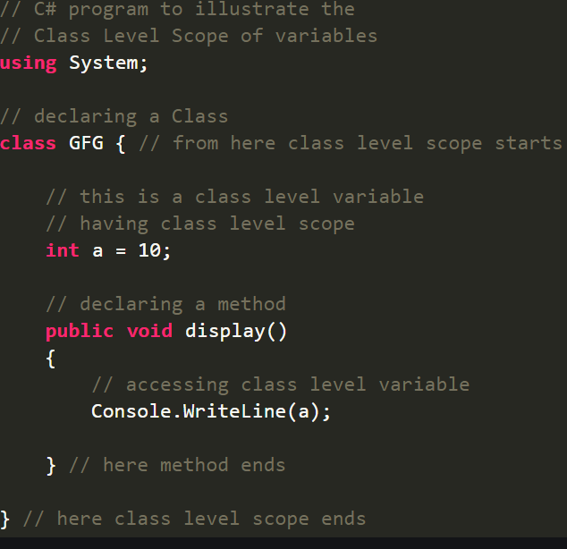

Method Level Scope

* Variables that are declared inside a method have method level scope. These are not accessible outside the method.
* However, these variables can be accessed by the nested code blocks inside a method.
* These variables are termed as the local variables.
* There will be a compile-time error if these variables are declared twice with the same name in the same scope.
* These variables don’t exist after method’s execution is over.

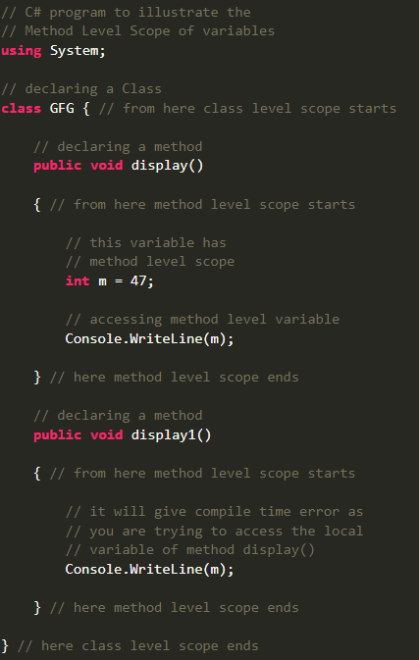

Block Level Scope

* These variables are generally declared inside the for, while statement etc.
* These variables are also termed as the loop variables or statements variable as they have limited their scope up to the body of the statement in which it declared.
* Generally, a loop inside a method has three level of nested code blocks(i.e. class level, method level, loop level).
* The variable which is declared outside the loop is also accessible within the nested loops. It means a class level variable will be accessible to the methods and all loops. Method level variable will be accessible to loop and method inside that method.
* A variable which is declared inside a loop body will not be visible to the outside of loop body.

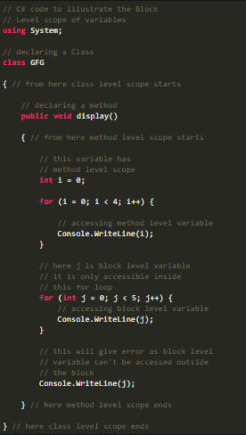

**8) Why do you think adhering to the general convention and standard practices is important as a software engineer**

1. Enhanced Efficiency

* Implementing programming standards and best practices would help the team to detect the problems early or even prevent them completely.

1. Risk of project failure is reduced
2. Many times, it happens that IT projects fail due to problems while developing software.
3. Minimal Complexity
4. Easy to Maintain
5. Bug Rectification
6. A Comprehensive Look
7. Cost-Efficient

**9) What are good coding practices in programming**

* Commenting & Documentation
* Code Refactoring
* Consistent Indentation
* Object-Oriented vs. Procedural
* Avoid Deep Nesting
* Separation of Code and Data
* Consistent Temporary Names
* Alternate Syntax Inside Templates
* Avoid Obvious Comments
* Code Grouping
* Capitalize SQL Special Words
* Consistent Naming Scheme
* DRY Principle
* Limit Line Length
* File and Folder Organization
* Use Meaningful Names for Variables and Functions

**10) What do you mean by fall-down effect in relation to the switch statement in Java**

*Fall through* is a situation that occurs when we miss out *break statement* with switch cases.

If we use break statement in the above program snippet, then we can avoid fall through.

**11) What is the difference between break and continue statements. Explain using a code sample**

Break Statement - The Break statement is used to exit from the loop constructs.

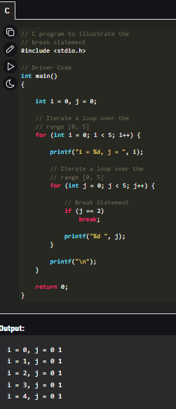

Continue Statement - The continue statement is not used to exit from the loop constructs.

